What Did Seaman Feel?

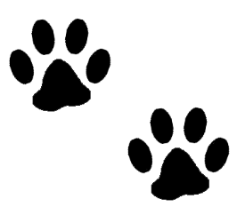

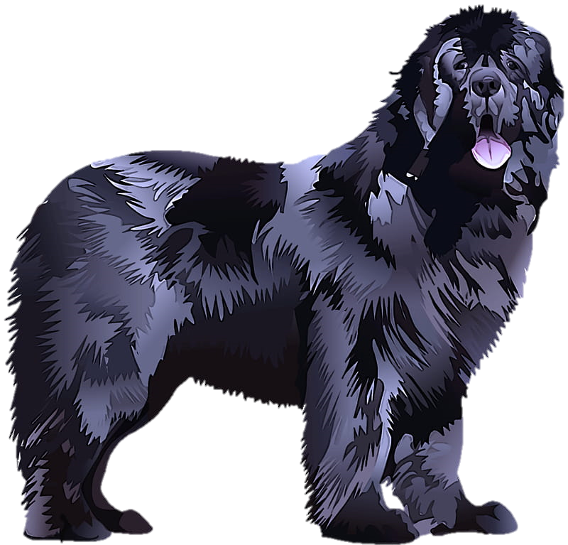









**Prickly Pear**

Prickly pear is a cactus like plant that has sharp skinny barbs. When Seaman stepped on these barbs it hurt his feet because his paw pads were unprotected. Lewis wrote in his journal, “My poor dog suffers with them, he is constantly biting and scratching himself as if in a rack of pain.” Even Lewis and Clark who wore moccasins were stabbed by this plant.

Have you ever touched anything prickly, like a cactus? Did it surprise you or hurt?

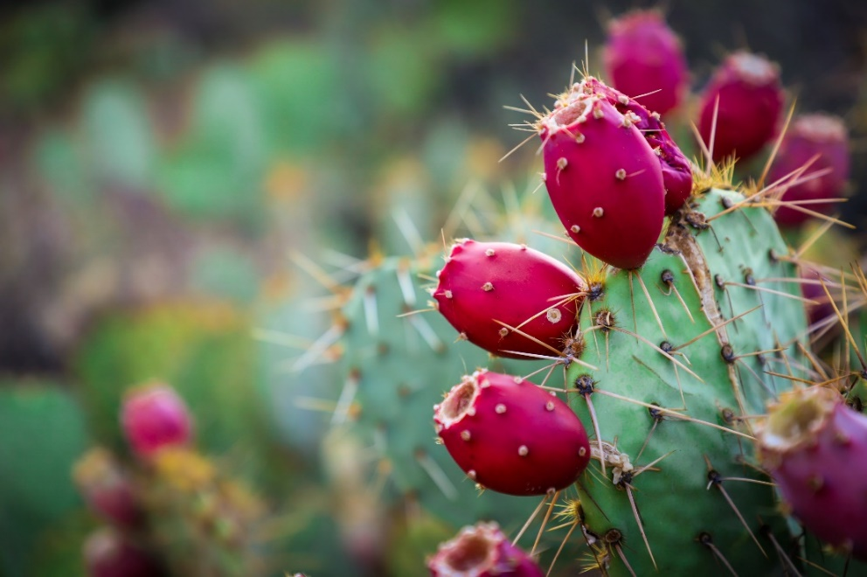

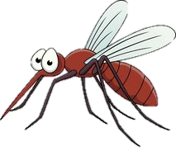

**Mosquito Bites**

Seaman’s coat was some protection against mosquitos, but his eyes and mouth were not protected. Lewis wrote in his journal, the mosquitos “were so numerous that we frequently get them in our throats as we breathe…My dog even howls with the torture he experiences from them.”



Have you ever been bitten by a mosquito or another insect? What did it feel like? Did it make you howl like I did when mosquitos bit me?

Extreme Cold and Heat

Sunny and

Rainy Weather

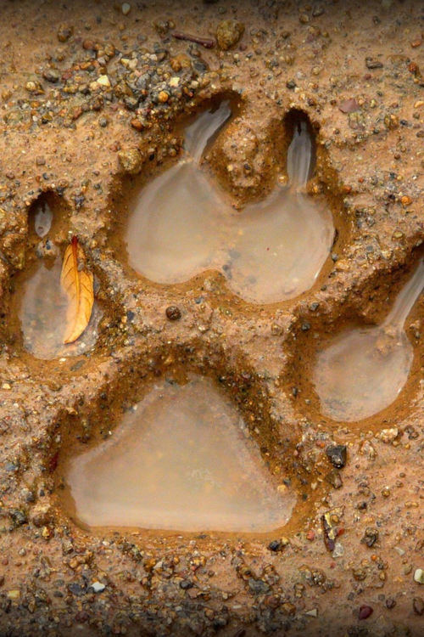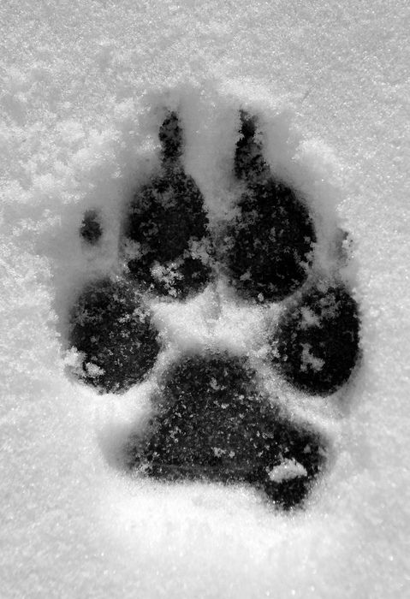

When it was cold we had fire to keep us warm and when I got too hot there was usually a stream or river I could cool off in. Since I am a Newfoundland breed I love to swim. My paws have webbing between my toes to help me swim and I have a lot of room in my lungs so I can swim for a long time!



**Activity**

Search around your house or outside to find something that is:

* Soft
* Hard
* Smooth
* Rough or bumpy
* Cold
* Warm

Or find things in your house or outside and describe what they feel like in your journal!